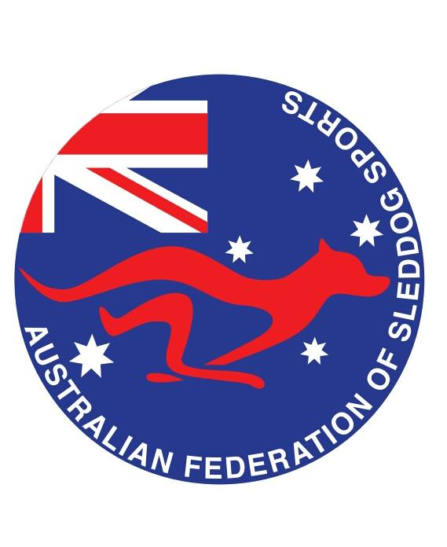

**Minutes of the Formation Meeting of the**

**AUSTRALIAN FEDERATION OF SLEDDOG SPORTS(AFSS) - INC1601474**

TUESDAY 8TH NOVEMBER 2016 – 2000HRS AEST

**Present:** Andrew Gersbach, Lisa Gersbach, Natalie McIllree, Mandy Graham, Justin Celentane, Kim Offner, Peter Rose, Michelle Rose, Emily Vourlides, Kath Hammond.

**Apologies:** none

The meeting commenced at 2000 AEST

AGENDA ITEMS

1. **Meeting opening**
2. **Apologies**
   1. None
3. **Review and Acceptance of previous minutes**
   1. none
4. **Business arising from previous Annual General Meeting**
   1. none

PROPOSED FORMATION OF THE AFSS

1. **Motion: Form the Australian Federation of Sleddog Sports**

It is proposed that the Australian Federation of Sleddog Sports is formed to provide a governing body to support individual Sled Dog Sports Clubs known as Race Giving Organisations in the act of recreational and racing dog powered sports activities.

**Moved: A Gersbach Seconded: E Vourlides Vote: Carried**

ELECTION OF MEMBERS

1. **Election of National Council and RGO Representatives**
   1. N McIllree appointed voting scrutineer
   2. **President**
      1. Andrew Gersbach – sole candidate – elected unopposed
   3. **Vice President**
      1. Emily Vourlides – sole candidate – elected unopposed
   4. **Secretary**
      1. Michelle Rose – sole candidate – elected unopposed
   5. **Treasurer**
      1. Justin Celentane – sole candidate – elected unopposed
   6. **Public Officer**
      1. Andrew Gersbach – sole candidate – elected unopposed
   7. **Victorian RGO Representative**
      1. Kim Offner – sole candidate – elected unopposed
   8. **South Australian RGO Representative**
      1. Mandy Graham – sole candidate – elected unopposed
   9. **Queensland RGO Representative**
      1. Kath Hammond – sole candidate – elected unopposed
   10. **New South Wales RGO Representative**
       1. Peter Rose – sole candidate – elected unopposed
   11. **Western Australian RGO Representative**
       1. Natalie McIllree – sole candidate – elected unopposed
   12. **Australian Capital Territory RGO Representative**
       1. Lisa Gersbach – sole candidate – elected unopposed

IMMEDIATE ACTIONS

1. **Motion: Fiduciary**

It is proposed that a Bank account be setup in the name of the Australian Federation of Sleddog Sports(AFSS) to manage member funds for the not for profit association. The responsibility of this action is to be held by J Celentane as Treasurer.

**Moved: A Gersbach Seconded: M Graham Vote: Carried**

1. **Motion: Constitution**

It is proposed to adopt the Model Rules for Incorporated Associations as provided by the NSW Department of Fair Trading.

**Moved: A Gersbach Seconded: K Offner Vote: Carried**

AGENDA ITEMS MOVED TO EARLIEST GENERAL MEETING

1. IFSS affiliation
   1. AFSS will seek associate membership with the IFSS
      1. Application has been submitted
2. Club Affiliation costs
   1. Committee based RGO only @ $200
   2. Clubs with membership @ $475
   3. Costs are designed in order for AFSS clubs to affiliate one race with ASSA to ensure point score continuity for all mushers
3. Insurance
   1. Insurance is underwritten by Lloyds of London and provided through PetPlan professional Insurance covering members anywhere in Australia.
   2. Group Accident is provided - $2500 excess per claim
   3. Public Liability is provided @ $20m
   4. Products Liability is provided @ $20m
   5. Includes member to member cover
   6. Excludes any liability arising from declared or deemed dangerous dogs
4. Individual membership costs
   1. Single Membership @ $25
   2. Family Membership @ $45
5. National Point Score model
   1. All Australian races shall be included in AFSS member pointscore calculations.
   2. Mushers top 4 results will be used in calculations
   3. 1 race out of your state is required for qualification
   4. Formula = WT/OT*100 = RPS
      1. Single heat race = RPS * 0.8
      2. Triple heat race = RPS * 1.2
6. Date of the inaugural AGM
   1. Pending, however it must occur within 6 months of the foundation meeting
7. Rules, Policy and Procedure guidelines
   1. IFSS Race Rules shall be adopted
      1. Proposing simplification for temperatures and dog ages
   2. Aggressive Dog Policy
   3. IFSS Procedures
   4. Sportsmanship Policy
   5. Adoption of Race Judge training/results – Pre or Post AFSS formation

Meeting closed at 2055 AEST